For the protection of your child’s confidential information, we have created the following secure procedures for establishing a parent portal account. To create a parent portal account online, you must have a valid email address and the student’s birth date must be on record with Pasco County Schools.
- Log on to the following Site: http://www.pasco.k12.fl.us/parents and select myStudent under the School/Classroom Resources section.

Note: When utilizing the myStudent app, you will select Create a Parent Portal Account in the bottom left
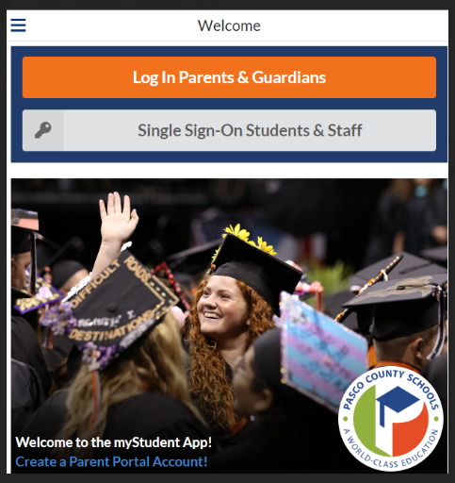 this will bring you directly to step 3

- You will select Parents: Click HEREto register for a new account.

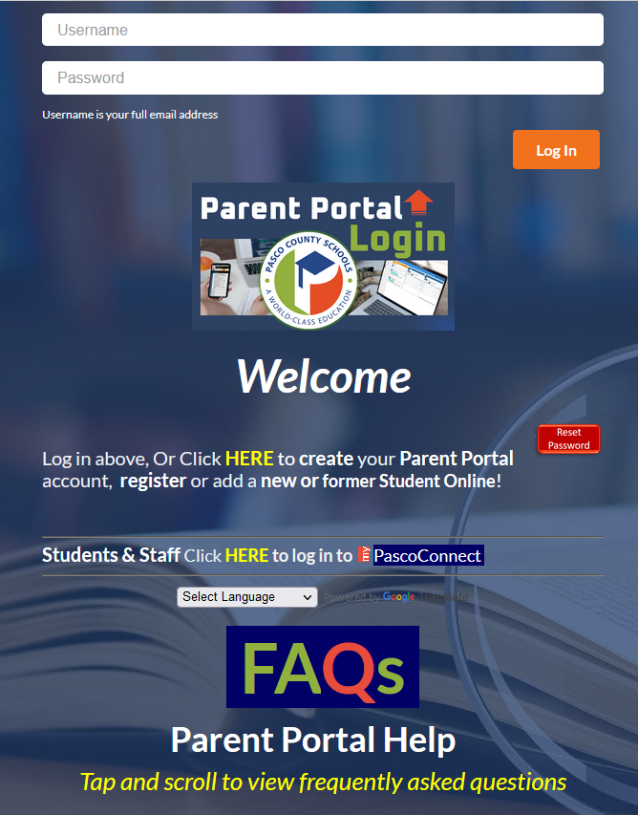

- On the entrance screen is a message with three (3) options to choose from:
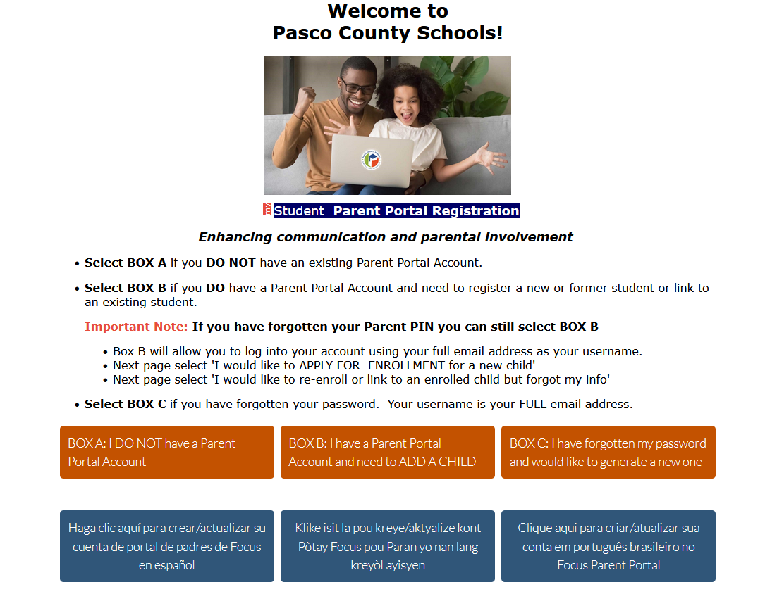
- If you do not yet have a parent account, click I DO NOT have a Parent Portal Account.
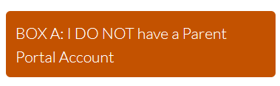

- Enter all of the required fields with your own information. Your child’s school has set up these requirements to create a parent account. Click Submit.

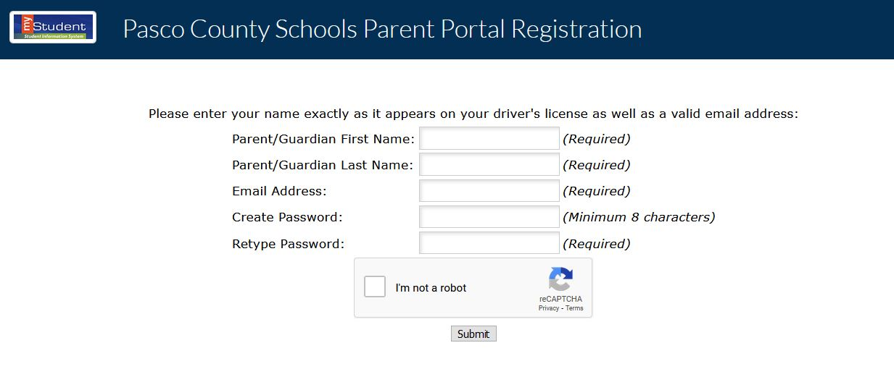

Clicking Box A: Will guide you in connecting your already enrolled student(s) to your parent account. You will need your student's Pasco student id, Date of Birth, and PIN (which may have been provided by the current school) to link the accounts. Note: There are additional methods for connecting to your child without the PIN.

Clicking Box B: Will guide the parent in creating a student record for their school age student that has never been enrolled in the Pasco County school system. This will enroll the student into the Applicant school with Pasco County to allow the parent to follow the school choice process and/or online registration.
Clicking Box C: You will select this once your student(s) are linked to your account.

Clicking Box D: You will select this to re-enroll or link to an enrolled child and forgot your information.

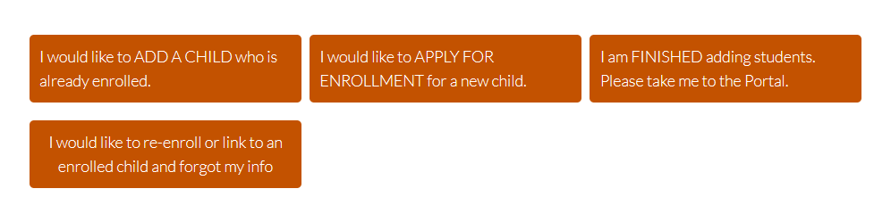
D
C
A
B

Note: For more assistance on support as you select box B, select here

For students already enrolled in a Pasco County School, select I would like to ADD A CHILD who is already enrolled.
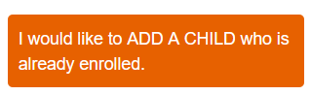

Enter the required information to identify your child. There are three requirements to link a student to a parent account from this screen. The PIN number is unique per student and may have been supplied from the child’s school. If another custodial parent already has access to the parent portal, they can provide the PIN, via the Parent Portal under the Parent Information page. Click Add Student to add multiple children.

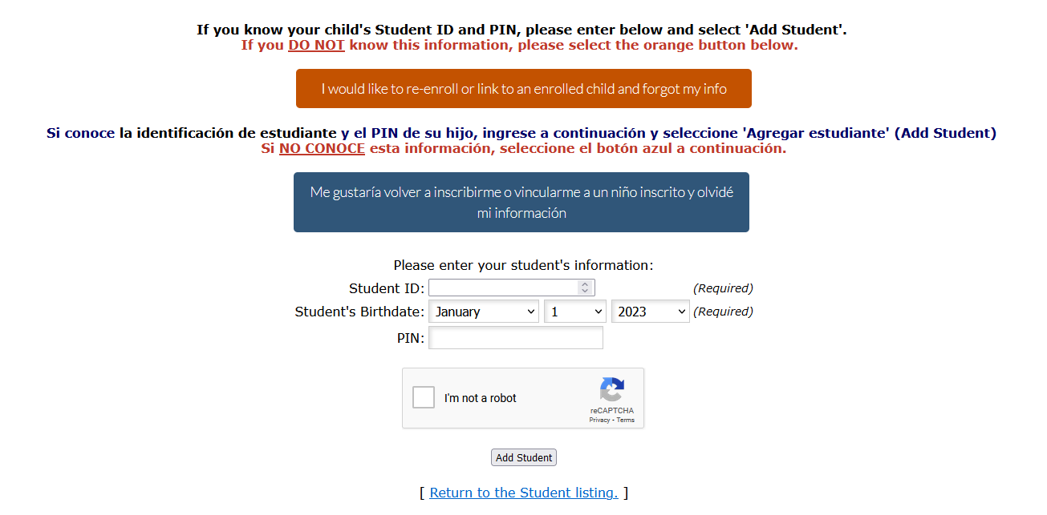
Note: Don’t worry, if you do not have the PIN, select the orange button “I would like to re-enroll or link to an enrolled child and forgot my info”. You will be redirected to complete a Link my Student form in order to link to your child.
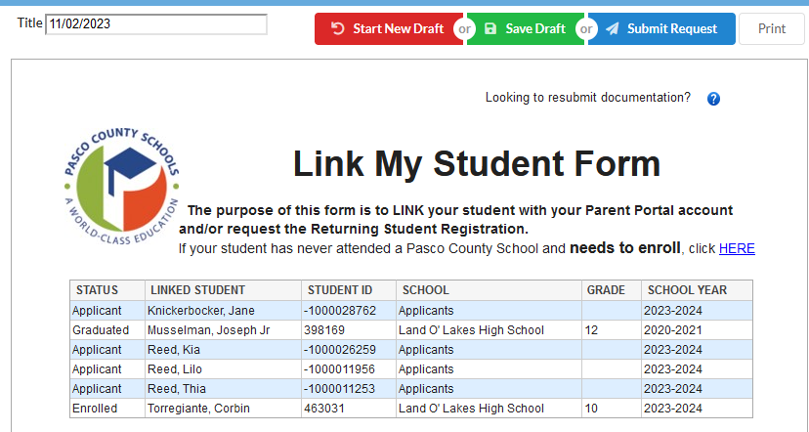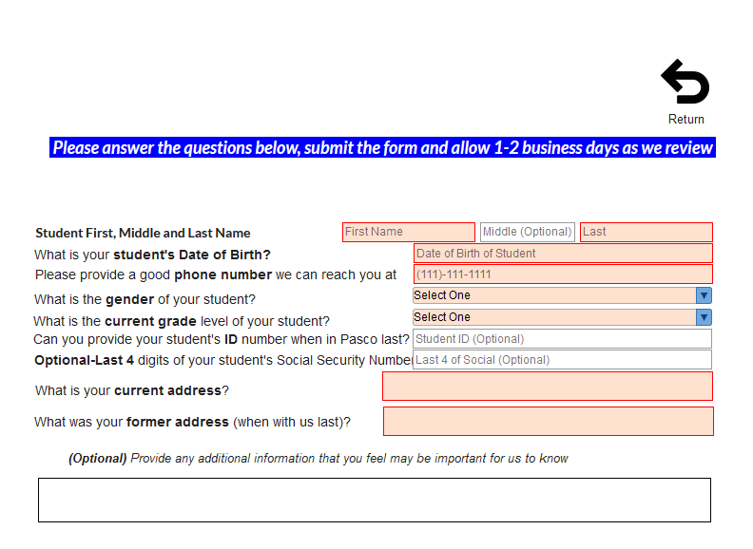
- Your child’s name will display on the screen. To add another child, click I would like to ADD A CHILD who is already enrolled. Otherwise, click I am FINISHED adding students. Please take me to the Portal.
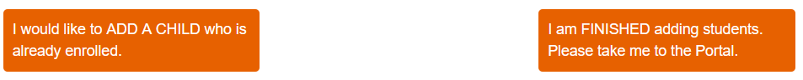

- To Add Another Child, enter all of the information required and click Add Student.

NOTE: This step can be completed as many times as necessary, or at a later date if needed.
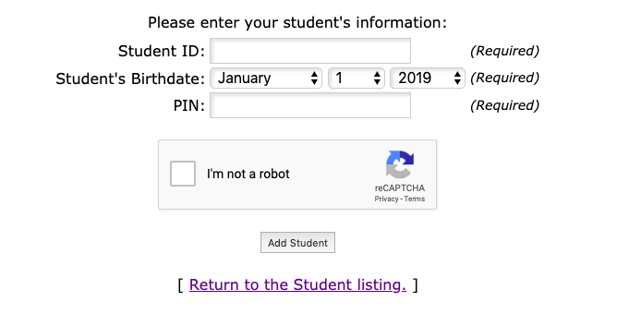
- You can access the portal by selecting, I am FINISHED adding students. Please take me to the portal.
- You will be prompted to acknowledge Parent and Legal Notices and any Pending Forms

- To access your Parent Portal, enter your new username and password on the Portal login screen. Click Log In. Username is the email address used to create the parent portal account. The password is the unique password chosen by the parent as they created a parent portal account.
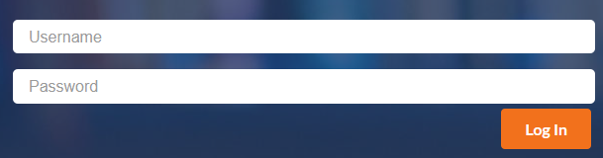

A. If you have forgotten your password, click the link at the bottom of the sign-on page

B. Enter the email address used to create your account and click the submit button. If the email address is not in the system, an error message will display.

