The Link my Student feature is now available to help you connect with your student(s). If your child has left Pasco and is now returning to re-enroll or you need to link to a child who is currently enrolled, select the appropriate link from the portal page.
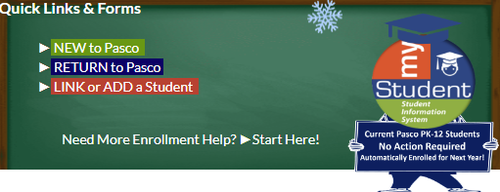
Linking to a child currently enrolled
- Select Link or Add a Student on the portal
- Select the orange box, I would like to re-enroll or link to an enrolled child and forgot my info
- The Link My Student form will display
- Students already linked to your account will display at the top
  - No action is needed, the student is already linked and/or the registration application is complete
- If the student isn’t displayed, select your child from the drop-down menu
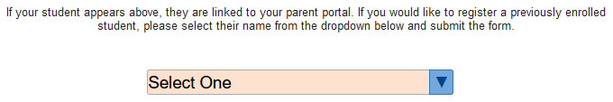
  - Complete the information to be linked with your student
- If the student is not available in the drop-down menu, select the check box for The student I want to link is not in the dropdown
- Select Unlinked Student from the drop-down menu
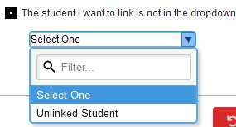

- Complete the following information
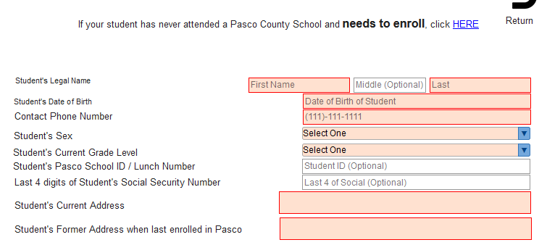

- Select the check box for the declaration statement
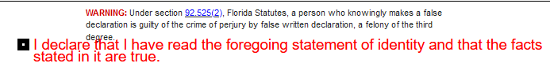
- Select the Click to Sign button

- Add your signature
- Select the Sign button
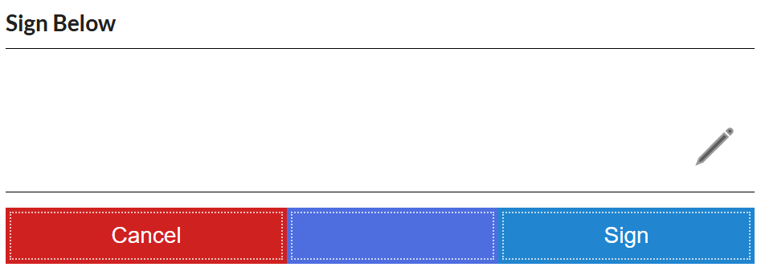
- Upload documents in the upload area
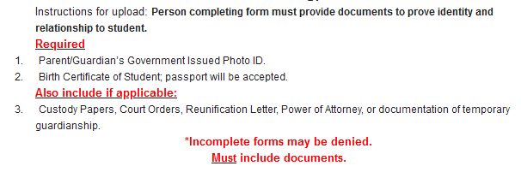
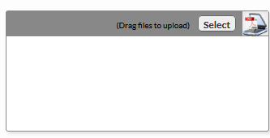
- Click Submit Request

- A submitted form confirmation will display

  - Click Print for a copy of your request
  - Click Start New Request, if you have another student to add
  - Select the Portal menu to return to the Portal
- You will be notified by email once the request has been reviewed to verify your identity and link you to your student
Re-enrolling a returning student
- Select the Return to Pasco button
- If the student you wish to re-enroll is listed in the dropdown, please select that student and click Submit Request
- A submitted form confirmation will display
  - Click Print for a copy of your request
  - Click Start New Request, if you have another student to add
  - Select the Portal menu to return to the Portal
- The Pending Forms will display on the portal
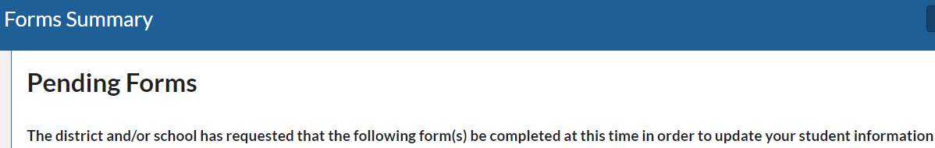
- Find and select the Returning Student Registration form to begin the application
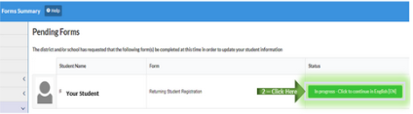
- If you have multiple students listed to re-enroll, please do this for each student
If you do not see your student listed
- Scroll down to find the check box for “The student I want to link is not in the dropdown”
- Select ‘Unlinked Student’ from the dropdown
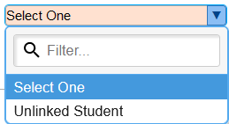
- Complete the necessary information to help us verify your identity to link with your student and Submit Request
  - Please repeat this process for each student you wish to link with

If you know your student is brand New-to-Pasco
- Select this link to begin the New Student Registration form

