Once you have created a Parent Portal Account and attached your students, you will be signed into the Portal. Parents can view useful notifications and information related to their child, including real-time alerts and messages through their Portal Page.
3
2
4
11
1
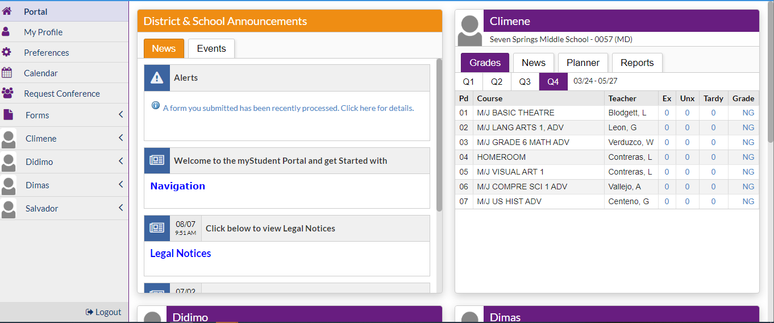
12
10
5
7
9
8
6
5

- myStudent Logo– Click on the logo to return to the portal page
- User Name – Displays your first and last name
- School Name – Displays the school for the selected child
- School year pull-down –Navigates between the current year and prior/future years
- Child(ren’s) name- Parents with multiple students can switch between their children by selecting the name on the left and accessing menu options or by selecting the tabs on each name card
- Marking Period – Displays a list of available marking periods during the school year. Defaults to the currently active marking period
- Main Menu- menus that allows users to navigate to different screens within myStudent
- News tab - Alerts-These are any alerts specific to the user’s child such as: Absences, Referrals, or Unpaid Fees. Welcome announcements or links, Legal Notices, Bus Routes, Student Fees
- Events tab- District/school calendar of upcoming events the user can click on the View Calendar link to view the school’s calendar for the entire year
- Student Card -Lists the user’s child’s/children’s classes along with their current grade for secondary schools, this is not available for Elementary level students.
- Grades tab - Clicking the course or grade links will take the user to the Assignments & Grades screen for the student’s class. (see below for Assignment details)
- News tab – School/Student specific information
- Planner tab – Displays Assignment Due Dates
- Reports tab – Displays downloads for Report Cards, Progress Reports, Test Scores
- Help- Provides Contextual help for the current page
- Logout- Closes the myStudent application, the system will time-out after 24 minutes of inactivity

My Profile – includes list of Attached Students, General and Parent Legal Notices
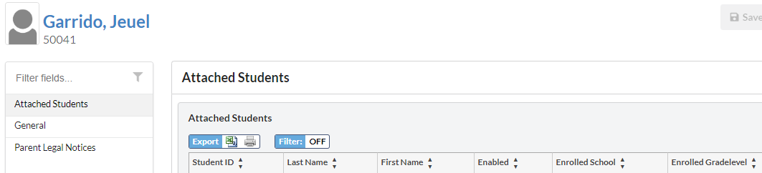

Preferences – includes Display Options, Notifications and Linked Accounts
Display Options tab
Allows Parents to configure the Language, Highlight Color, Portal Student Name Format, Student Info Layout, Default Filters On and the Date Format.
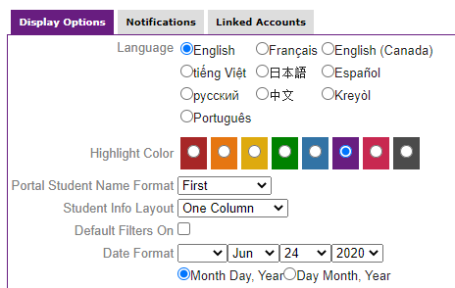
Notifications tab
Allows the user to set the frequency and type of notifications

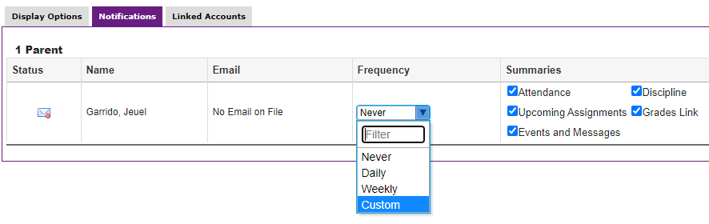
Note: A Daily or Weekly selection does not give options for threshold notifications.

Custom notifications can be selected as an option for Frequency.
Options are available to set thresholds for when notifications are sent, to the email address on file, regarding grades, absences and discipline.
Note: Some notifications are only available for Secondary level students.
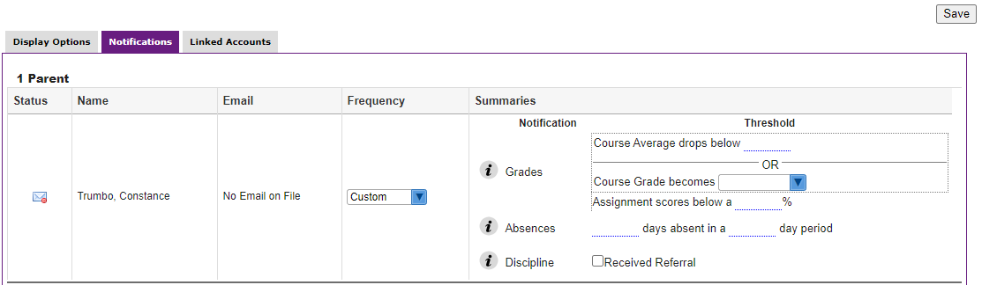
6
4
1
2
3
5
  - The email that will receive notifications.
  - Frequency of notifications. (Daily, Weekly or Custom) Only the Custom option provides the choices for Grades, Absence and Discipline thresholds.
  - Grades - Enter a course grade average, course letter grade or Assignment score % as a threshold. (Secondary)
  - Absences - Select the number of days absent within a specified number of days.
  - Receive notice if the student receives a referral
  - Select Save to update changes.
Note: Hovering or clicking on the will give the user instructions.

Calendar – An interactive calendar
4
3
1
2
  - Use arrows to switch months
  - Display – select Assignments, Lessons or Units
  - Select the + symbol to add events
  - Choose between Month or Week display

Request Conference – Tab selections include Make a Request, Pending Requests or Approved/Denied Requests

6
5
1
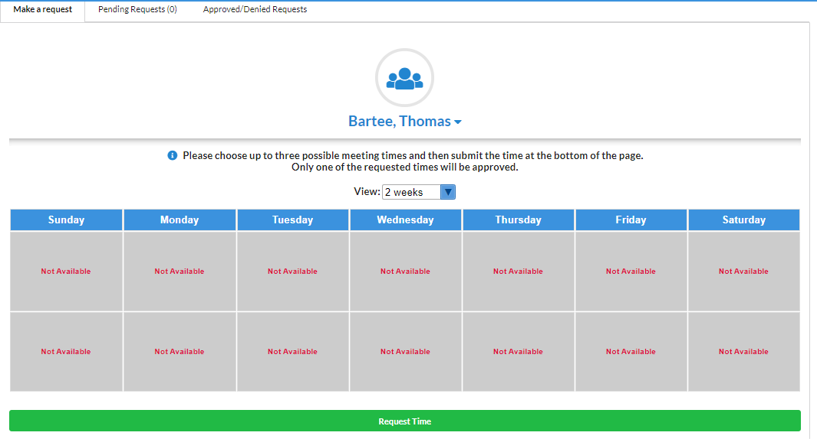
4
3
2
- Make a Request tab
- Select Teacher from the drop-down menu
- Select Weeks to view and select days/times
- Select Request Time to submit for approval
- Pending Requests submitted for approval
- Approved/Denied Requests

Forms – Mulitiple Links to available online forms - only select forms that pertain to your child.
- Forms can be submitted by selecting Save
- Forms can be saved for a later date by selecting Save and Continue
- Select Forms and select the link of the form needed for completion

My Child Menu
The myStudent Parent Portal is a tool designed to enhance parent’s access to their child’s education. Parents can review their student’s information, schedule, attendance and more. The My Child menu shows each of the pieces the user, as the parent, can access.

The following section reviews the My Child menu options:
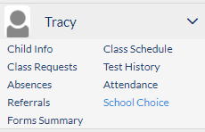
Child Info
The Child Info screen lists demographic information regarding the user’s child. Parents can review any of the information for accuracy and contact the school if changes should be made. Select a child from the side menu, if there are multiple children to select.
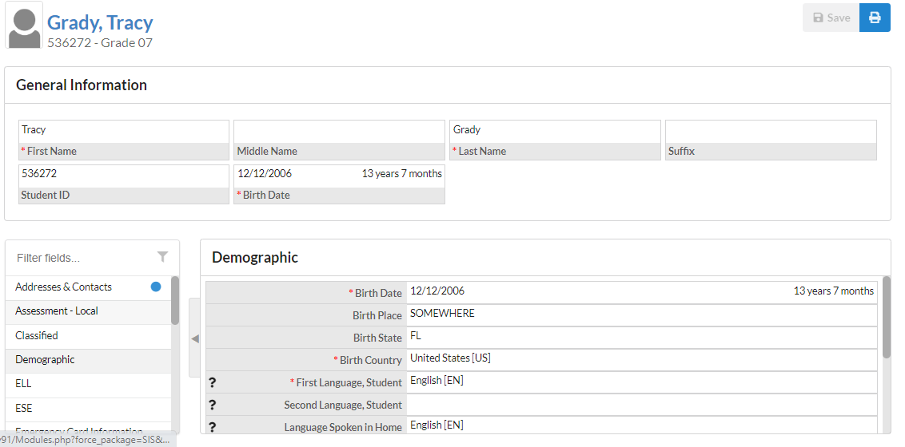
5
4
3
1
2
- This is the student’s name. By clicking on the name, a box will appear with the General Information of the student.
- This General Information area can collapse by clicking on the student’s name.
- Numerous menu options allow the user to view information for the student. The Filter Fields box can be used to search for a specific screen.
- The Parent Information menu contains:
- Student Password
- Parent PIN
- Lunch Balance
- PIN for Account use at School Vending Machines
- Student Personal Email Address -can be edited by student and parent
- Student Preferred Phone -can be edited by student and parent
- The user can click the arrow to close the list of screens and expand the student information section of the screen.
Note: Clicking on the arrow will reopen the list of screens.
- The main screen will display the information/screen selected

Class Requests – For 6 – 12th grade students only. Displays course requests entered at the school level.
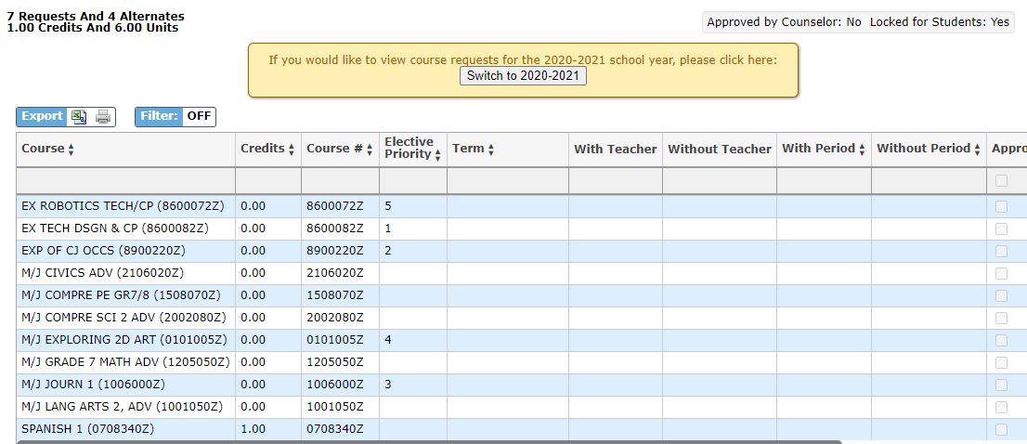
Absences
The Absences Sub-menu displays an Absence Summary of the student’s attendance.
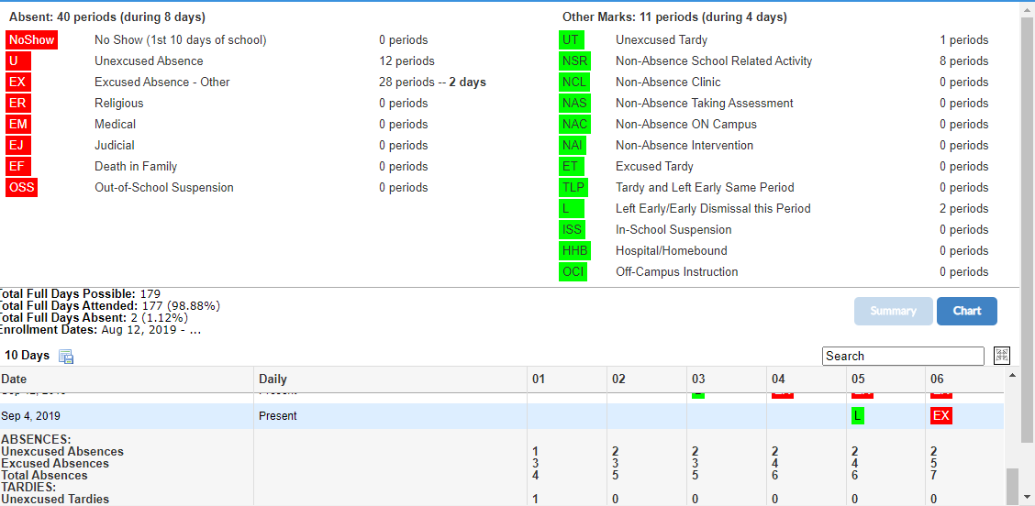

Referrals
The Referrals Sub-menu allows users to view a list of referrals the student has received.

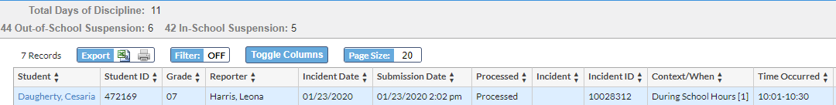

To view referral details, click link on student name.
Forms Summary – displays Available and Completed Forms
- Select View Changes button to view the changes submitted
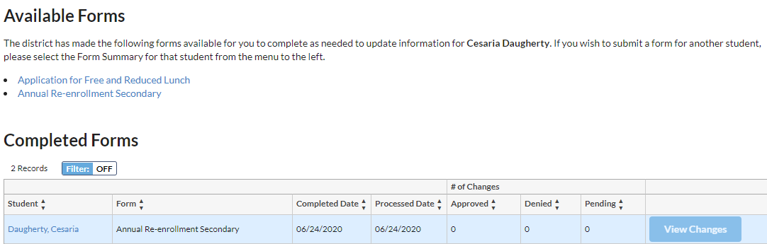
Class Schedule
The Schedule Sub-menu displays the student’s current schedule
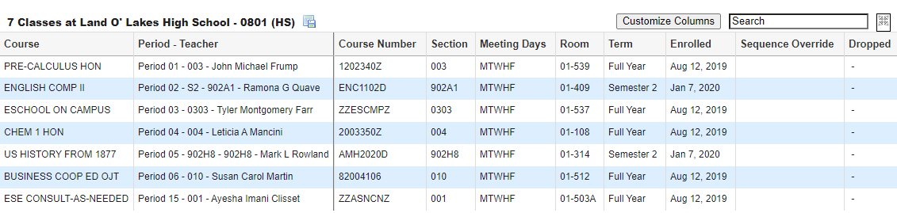
Test History
The Test History Sub-menu displays a list of all imported tests the student has taken. It also displays the administration date, the school year, and grade level for each test.

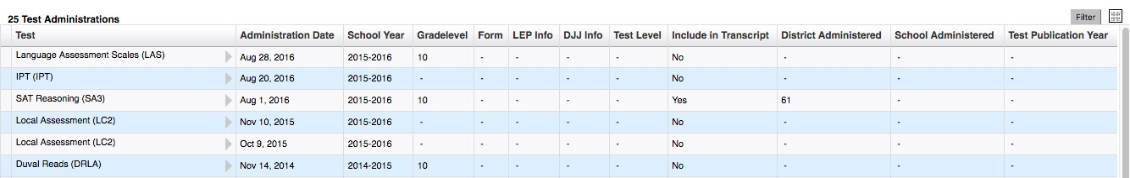

Attendance
The Attendance Sub-menu displays a chart with Daily or Period Attendance by Course within the Report Timeframe selected. May switch between Summary or Chart View.
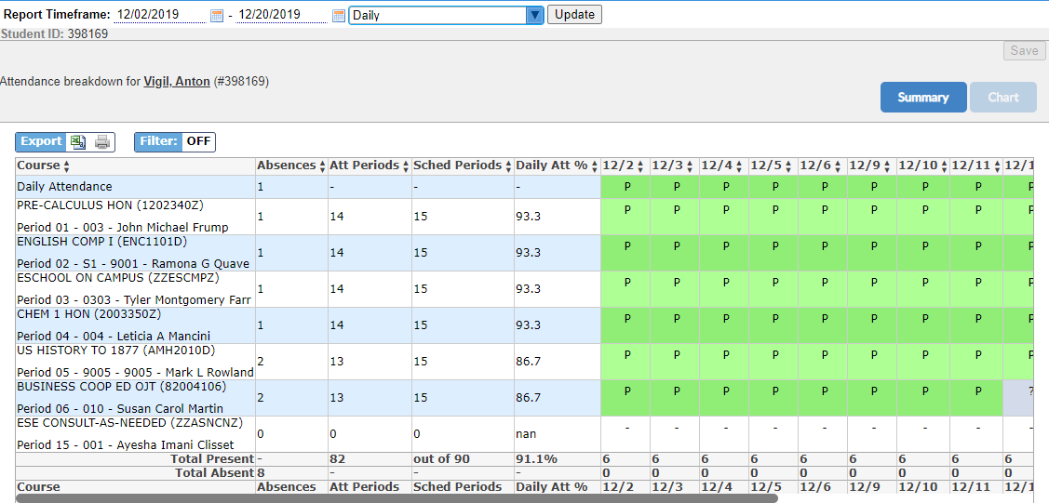

School Choice
The School Choice Sub-menu displays school choice selections.

Grades Tab - Accessing Assignments & Grades - (SECONDARY Students ONLY)
Parents can monitor their child’s progress in school by selecting the Grades tab from the Student Record Card along with the appropriate Marking Period. By selecting the Grade column for each course, it provides access to both assignments and grades that are entered by the teacher throughout the school year.

The Assignments & Grades menu lists all the classes, at the selected school, that your child in enrolled in.

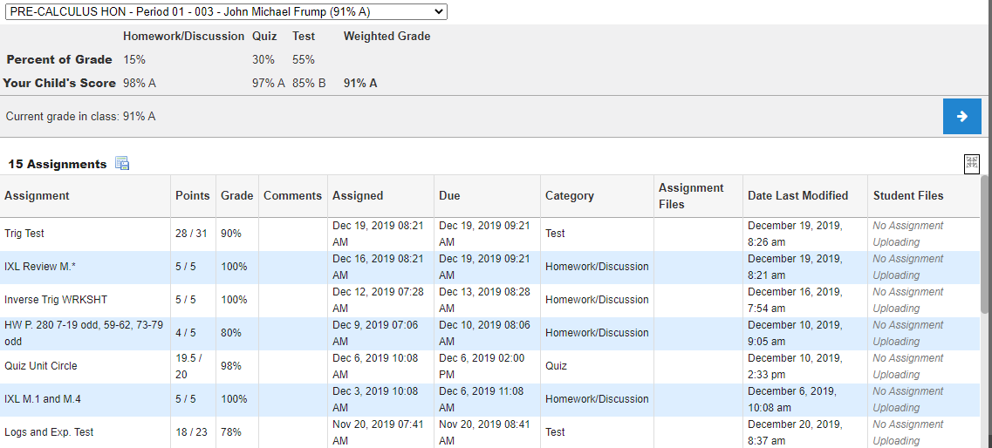

Once the user selects a class, a detailed view of your child’s performance appears. From this screen, the parent can see a detailed breakdown of the classroom assignments. Listed at the top of the screen is a breakdown of the classroom assignment categories and their percentage towards final grade. Under the Percent of Grade, your child’s score in each category is listed. The assignments section lists all of the tests, classwork, homework, projects etc. for the class. Each assignment grade, possible points, grade percentage, teacher comments, assigned date, due date, category, related files are viewable and date of last modification.

Viewing Marking Period Final Grades (ELEMENTARY and SECONDARY Students)
At the end of a marking period, parents can log in to see final grades. A download to view Progress Reports and Report Cards will be available under the Reports tab on the student card. Once the marking period is over, parents will notice the course grades will reset to “Not Graded” at the beginning of a marking period.
FREQUENTLY ASKED QUESTIONS:

- WHO SHOULD USE myStudent Parent Portal?
myStudent Parent Portal is available to all parents or guardians of Pasco County School District for students PK-12.

- HOW DO I CREATE AN ACCOUNT?
Visit the Pasco County Schools Website (pasco.k12.fl.us) and select the Parents link in the top blue ribbon. Select the myStudent option under School/Classroom Resources. Select Click Here to register. If your child was previously enrolled and you don’t have access to the PIN, please select the box to add a child, then the box to re-enroll or link to an enrolled child and forgot my info.

- WHAT HAPPENS WHEN MY CHILD MOVES TO ANOTHER SCHOOL?
myStudent Parent Portal accounts roll over from year to year, so when your child moves from middle to high school, you do not have to create a new account. Also, if your student moves to another school within Pasco County, your account will be updated with the new school information once the enrollment is complete.
- WHAT IF I CAN’T REMEMBER MY PASSWORD?
If you have forgotten your username or password, please select Forgot Password? from the parent login screen. You will be emailed with a replacement password that you can use to login, then reset the password to a selection of your choice after re-entry.

- HAVING PROBLEMS?
If you are experiencing problems with logging in or navigating the site, please contact Tech Help at 813-794-2859 or select Need Help? From the parent login screen. If you have questions about your student’s information, such as grades, attendance, discipline, or addresses and contacts, please contact your student’s school.

